TASK 1 – Artifacts

1. Write a program to print numbers from 10 to 50 using for/while loop

2. Write a program to find given number is positive or negative

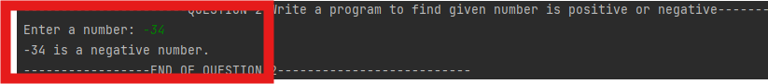

3. Program to print the entered number in reverse

4.Program to find smallest of given number

5.Program to print discount applied for purchase amount

6. program to Print the pattern as below

55555

54444

54333

54322

54321

